- Revenue & Profit by Region
SELECT Region,
SUM(Revenue) AS TotalRevenue,
SUM(Profit) AS TotalProfit,
COUNT(*) AS OrderCount
FROM dbo.Retail_Sales_2026
GROUP BY Region
ORDER BY TotalRevenue DESC;
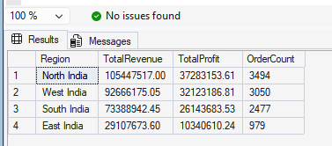
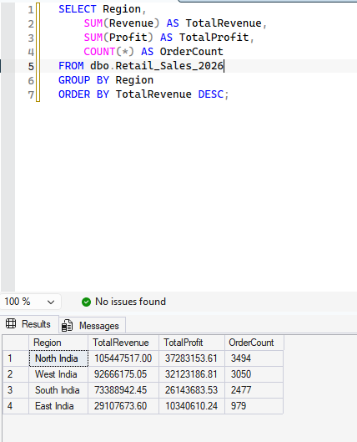

- Revenue & Profit by Category

SELECT Category,
SUM(Revenue) AS TotalRevenue,
SUM(Profit) AS TotalProfit,
AVG(Margin_Pct) AS AvgMarginPct
FROM dbo.Retail_Sales_2026
GROUP BY Category
ORDER BY TotalRevenue DESC;

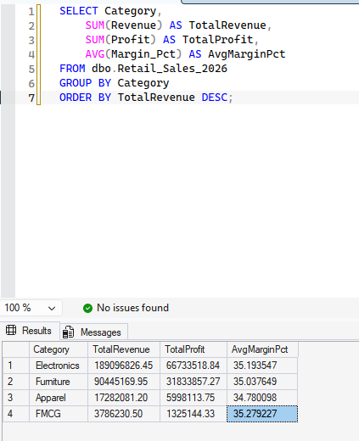

Top 10 Products by Revenue
SELECT TOP 10 Product,
SUM(Revenue) AS TotalRevenue,
SUM(Quantity) AS UnitsSold,
SUM(Profit) AS TotalProfit
FROM dbo.Retail_Sales_2026
GROUP BY Product
ORDER BY TotalRevenue DESC;

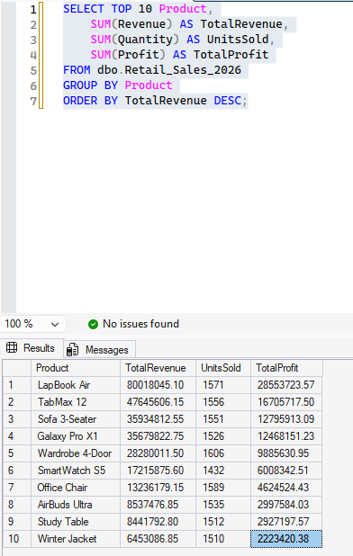

Monthly Revenue & Profit Trend
SELECT FORMAT(OrderDate, 'yyyy-MM') AS YearMonth,
SUM(Revenue) AS TotalRevenue,
SUM(Profit) AS TotalProfit
FROM dbo.Retail_Sales_2026
GROUP BY FORMAT(OrderDate, 'yyyy-MM')
ORDER BY YearMonth;

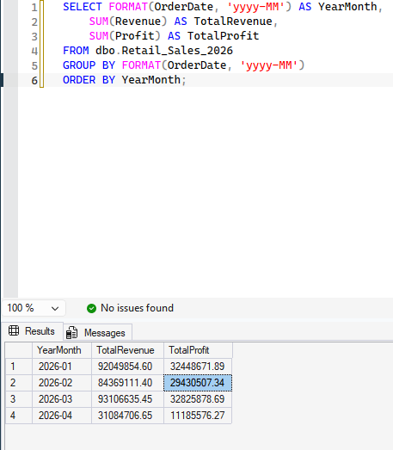

Discount Impact on Margin

SELECT
CASE
WHEN Discount_Pct = 0 THEN 'No Discount'
WHEN Discount_Pct BETWEEN 1 AND 10 THEN '1-10%'
WHEN Discount_Pct BETWEEN 11 AND 20 THEN '11-20%'
ELSE '20%+'
END AS DiscountBand,
COUNT(*) AS OrderCount,
AVG(Margin_Pct) AS AvgMarginPct,
SUM(Profit) AS TotalProfit
FROM dbo.Retail_Sales_2026
GROUP BY
CASE
WHEN Discount_Pct = 0 THEN 'No Discount'
WHEN Discount_Pct BETWEEN 1 AND 10 THEN '1-10%'
WHEN Discount_Pct BETWEEN 11 AND 20 THEN '11-20%'
ELSE '20%+'
END
ORDER BY AvgMarginPct DESC;
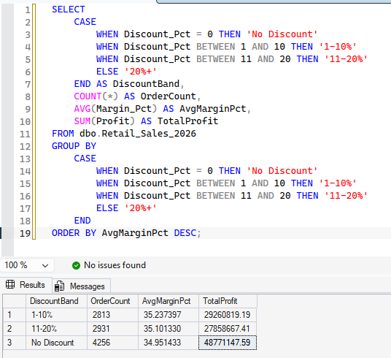

Channel Performance (Online vs Offline vs Partner)

SELECT Channel,
SUM(Revenue) AS TotalRevenue,
SUM(Profit) AS TotalProfit,
SUM(CAST(Returned AS INT)) * 100.0 / COUNT(*) AS ReturnRatePct
FROM dbo.Retail_Sales_2026
GROUP BY Channel
ORDER BY TotalRevenue DESC;
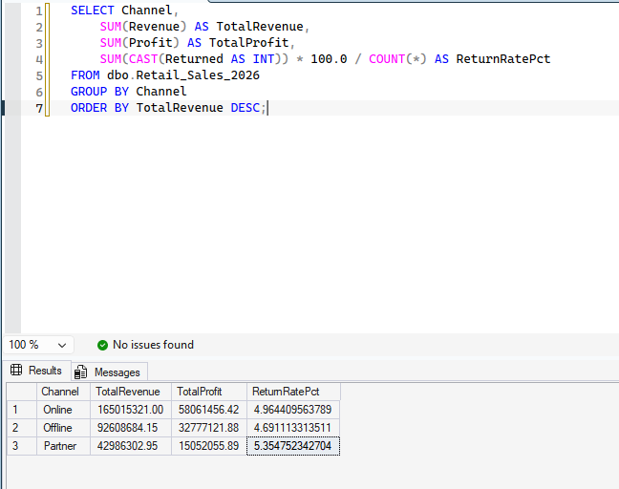

Summary

Revenue & Profit by Region
North India leads clearly on both revenue and profit, followed by West India, South India, and East India trailing. This lines up with the city list you saw earlier (Delhi, Gurugram, Noida, Jaipur, Chandigarh, Agra, Lucknow all sit in North India) — that region simply has more cities/customers represented.

Revenue & Profit by Category
Electronics dominates revenue and profit by a wide margin — makes sense given the high unit prices (LapBook Air, Galaxy Pro X1, TabMax 12 are all ₹25K–55K items). Furniture is a solid second. FMCG has the lowest revenue, which is expected since those are low-ticket items (₹120–1899), even though they likely have the highest order volume.

Top 10 Products
The big-ticket Electronics items (LapBook Air, TabMax 12, Galaxy Pro X1) top the list — a handful of expensive SKUs are driving a disproportionate share of total revenue. Worth checking: are these also your best margin performers, or just highest revenue?

Monthly Revenue & Profit Trend
Revenue looks broadly stable/trending across Jan–Apr 2026, with no major seasonal spike or dip. Since this dataset likely only spans Q1–Q2 2026 (per your earlier Quarter column showing Q1/Q2 only), there isn't a full year to see true seasonality yet.

Discount Impact on Margin
This is the most actionable one — margin % clearly declines as discount band increases. "No Discount" and "1–10%" bands protect margin best; the "20%+" band shows the weakest average margin. This suggests heavy discounting (20%+) is eating into profitability more than it's driving proportional volume gains — worth flagging if that's a live decision your business is making.

Channel Performance
Worth double-checking this one specifically — how close are Online, Offline, and Partner on revenue, and does one channel have a meaningfully higher return rate than the others? That's usually the most decision-useful cut in this table.
A few natural next steps if you want to go deeper:
- Margin by product (not just revenue) — to see if your top revenue products are actually your most profitable ones
- Region × Category cross-tab — which regions are strong in which categories
- Customer-level analysis — repeat customers vs one-time, using CustomerID

1. Margin by Product (not just revenue)
This checks whether your top revenue products are actually your most profitable ones — sometimes a high-revenue product has thin margins.
SELECT Product,
SUM(Revenue) AS TotalRevenue,
SUM(Profit) AS TotalProfit,
AVG(Margin_Pct) AS AvgMarginPct,
SUM(Quantity) AS UnitsSold
FROM dbo.Retail_Sales_2026
GROUP BY Product
ORDER BY AvgMarginPct DESC;
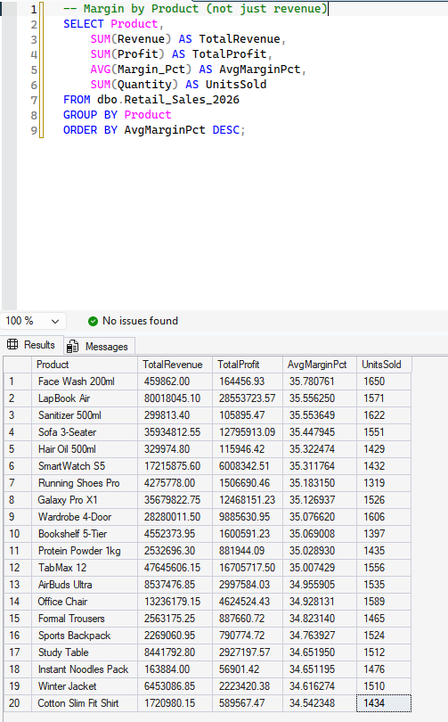

2. Region × Category Cross-Tab
Shows which categories are actually driving each region's revenue — useful for stocking/marketing decisions by region.
--Region × Category Cross-Tab
SELECT Region, Category,
SUM(Revenue) AS TotalRevenue,
SUM(Profit) AS TotalProfit,
COUNT(*) AS OrderCount
FROM dbo.Retail_Sales_2026
GROUP BY Region, Category
ORDER BY Region, TotalRevenue DESC;

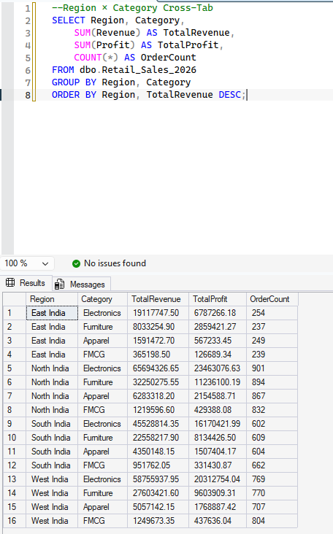

3. Customer-Level Analysis (repeat vs one-time)
-- Step A: orders per customer
SELECT CustomerID,
COUNT(*) AS OrderCount,
SUM(Revenue) AS TotalRevenue,
SUM(Profit) AS TotalProfit
FROM dbo.Retail_Sales_2026
GROUP BY CustomerID
ORDER BY OrderCount DESC;

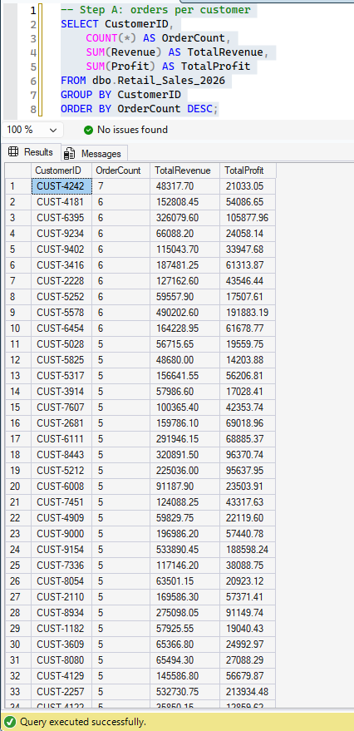
-- Step B: repeat vs one-time customer summary
SELECT
CASE WHEN OrderCount = 1 THEN 'One-Time' ELSE 'Repeat' END AS CustomerType,
COUNT(*) AS NumCustomers,
SUM(TotalRevenue) AS TotalRevenue,
AVG(TotalRevenue) AS AvgRevenuePerCustomer
FROM (
SELECT CustomerID, COUNT(*) AS OrderCount, SUM(Revenue) AS TotalRevenue
FROM dbo.Retail_Sales_2026
GROUP BY CustomerID
) AS CustomerSummary
GROUP BY CASE WHEN OrderCount = 1 THEN 'One-Time' ELSE 'Repeat' END;

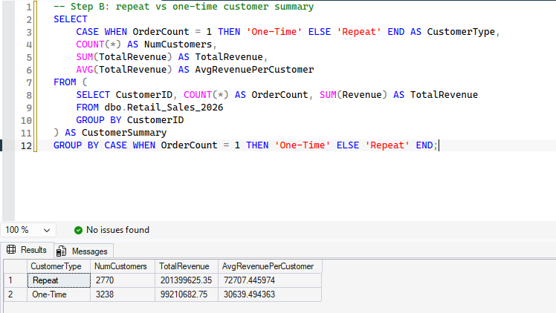

One more worth adding: Segment performance
Since you have Segment (Enterprise/SMB/Retail/New-Trial) already validated, it's a quick add:
--Segment performance
SELECT Segment,
SUM(Revenue) AS TotalRevenue,
SUM(Profit) AS TotalProfit,
AVG(Margin_Pct) AS AvgMarginPct,
COUNT(*) AS OrderCount
FROM dbo.Retail_Sales_2026
GROUP BY Segment
ORDER BY TotalRevenue DESC;

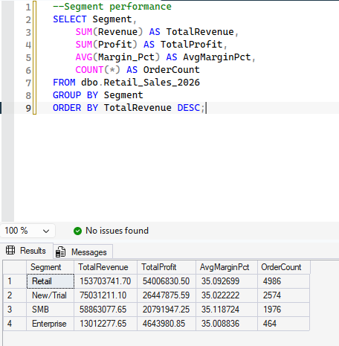

1. Margin by Product — surprise finding
Margins are actually very tight across all products (34.5%–35.8%), unlike revenue which varies wildly. Notably:
- Face Wash 200ml (a cheap FMCG item) has the highest average margin (35.78%) — beating LapBook Air, your top revenue product
- Cotton Slim Fit Shirt has the lowest margin (34.5%)
Takeaway: your high-revenue Electronics products aren't necessarily your highest-margin ones — margin is fairly flat across the whole catalog, so revenue concentration in Electronics is really a volume/price story, not a margin story.

2. Region × Category Cross-Tab
Electronics is the #1 category in every single region — that pattern holds nationally, it's not a regional quirk. Furniture is consistently #2 everywhere. This tells you Electronics isn't a regional strength, it's a company-wide demand driver.

3 & 4. Customer Analysis — this is the standout insight
- 2,770 repeat customers generated ₹20.1 crore in revenue (avg ₹72,707/customer)
- 3,238 one-time customers generated only ₹9.9 crore (avg ₹30,639/customer)
Repeat customers are ~46% of your customer base but drive ~67% of total revenue, and spend 2.4x more per customer than one-timers. This is a strong, clear signal: retention is where the real value is. Converting even a modest share of one-time buyers into repeat buyers would likely move revenue more than acquiring new customers.

5. Segment Performance
Retail segment leads on both revenue and profit share, followed by New/Trial, SMB, and Enterprise last — margins are nearly identical across all segments (~35%), so again, no segment is disproportionately more profitable per rupee — the difference is purely volume.

The headline story emerging from your data:
- Margins are flat everywhere (~35%) — profitability isn't about what you sell, it's about how much you sell
- Electronics drives volume-based revenue nationally, in every region
- Repeat customers are your most valuable asset — far more than any product or region cut

Natural next step
Given finding #3 is the strongest lead, it's worth digging one level deeper:
-- What do repeat customers buy vs one-time customers?
SELECT
CASE WHEN OrderCount = 1 THEN 'One-Time' ELSE 'Repeat' END AS CustomerType,
Category,
SUM(Revenue) AS TotalRevenue
FROM dbo.Retail_Sales_2026 rs
JOIN (
SELECT CustomerID, COUNT(*) AS OrderCount
FROM dbo.Retail_Sales_2026
GROUP BY CustomerID
) cs ON rs.CustomerID = cs.CustomerID
GROUP BY CASE WHEN OrderCount = 1 THEN 'One-Time' ELSE 'Repeat' END, Category
ORDER BY CustomerType, TotalRevenue DESC;
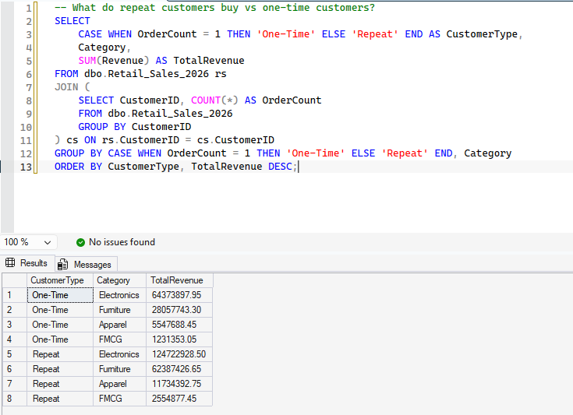

Category | One-Time Share | Repeat Share
Electronics | ~64.9% | ~61.9%
Furniture | ~28.3% | ~31.0%
Apparel | ~5.6% | ~5.8%
canFMCG | ~1.2% | ~1.3%
The proportions barely shift. This tells you repeat customers aren't buying a different mix of products — they're just buying more of the same mix, more often. So retention isn't a category-specific play (no single category is "the retention driver"); it's a frequency/loyalty play across the board.

Updated headline story
- Margins are flat (~35%) across every product, category, and segment — profitability scales with volume, not product mix
- Electronics leads everywhere — every region, both customer types — it's the demand backbone of the business
- Repeat customers are the highest-value asset: 46% of customers, 67% of revenue, 2.4x spend per customer — and they simply buy more, not differently

